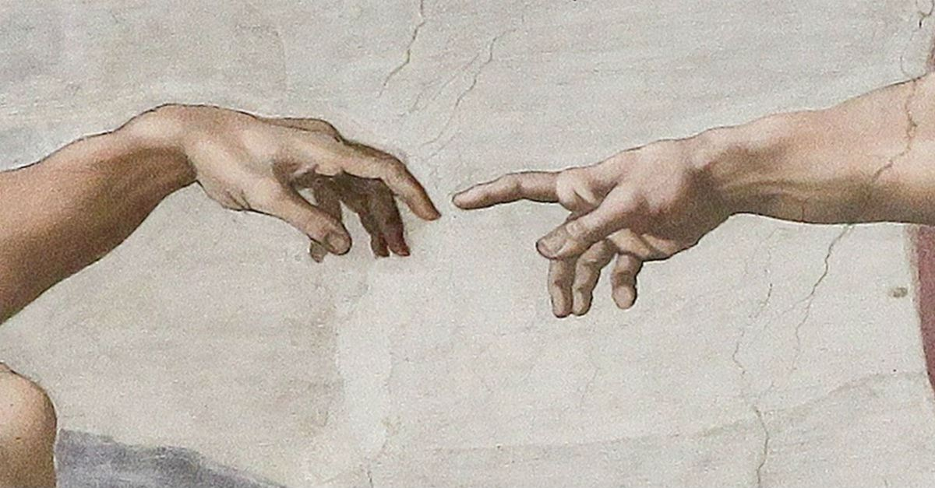

Imago Dei – 12th Comenius Conference

In a time when 3D printers can reproduce damaged bone-structures and when genetic modification and gender transformation allow for altering the given human body, it is time to reflect on the theological question what it means to be human. Are we just biological beings, not substantially different from other living beings? Or are we created in the image of God, having a special value and dignity over all creatures? Is Christian anthropological thinking outdated in our days of enormous technological and societal change? Or does it counterbalance human self-indulgence, having a pressing urgency and relevance? The 2020 Comenius conference in the beautiful city of Pápa, Hungary (April 22–25) discusses the issue under the notion of Imago Dei.
The testimony of Gen 1:27: “God created man in his own image” has a variety of theological meanings and implications. The special place of humankind in creation is often recognized in the ability of (abstract) thinking, speaking, creativity. This raises philosophical and ethical questions. Can rationality define humans and set them apart from other creatures? What does it mean for the appreciation of mentally handicapped people? Can such an understanding of human superiority be maintained in face of contemporary developments towards the post-human (cyberanthropology), genetic manipulation, and animal philosophy?

Christian anthropology

Many systematic theological issues are involved. Gen 1:27b (“male and female he created them”) implies that humankind is created for communion. To be human means to be a personal being in a communion of love. How does such an anthropology relate to the Christian understanding of the Trinity, a fundamentally relational notion? Is creation primarily receptive of divine grace or also responsible for Imitation of Christ? What are the consequences regarding globalization, national identity, gender, environment, consumerism?
This involves practical-theological issues as well. Humankind is not only created by the Word of God but also for the Word of God. To be able to respond to God entails accountability. The command “Be fruitful and multiply, … and have dominion…” (Gen 1:28) does not mean that humankind is the ruler of the world, only the representation of God’s rule on earth. How can we communicate the rule of God, or the responsibility and accountability of humankind concerning the creation toward the Creator and the people of modern ages? Or, from a different angle, what are the implications of Christian anthropology for the sub-disciplines of practical theology, such as diaconal studies, pastoral care, homiletics, religious education etc.?

Sin and the Fall

The notion of Imago Dei has a larger biblical context, raising numerous questions. How, for instance, does it relate to the Fall? How could this happen, when Adam and Eve were supposed to be like God? How should we understand sin; and how does this relate to the likeness of God? Do we need a theory of creation to understand this matter, or is the atonement fundamental for our understanding of the Imago Dei?
Not only Old Testament, but also New Testament exegetical questions are involved. Is a spiritual interpretation of Imago Dei supported by Jesus’s definition of God (“God is spirit”, John 4:24)? How is Christ the image of God as a perfect reflection of the glory of God? What does Paul teach about the new creation and new nature in connection with the image of God? In what way does our Christology influence our understanding of humanity?
Thinking about Christian anthropology obviously has a long history. Perhaps doing theology is thinking about the relation between God and humanity, and important developments in the history of Christianity are connected to anthropological considerations. Both in its own right, and in order to understand the otherness of our own times, historical questions are called for. For instance: Why did the patristic fathers distinguish between the image and the likeness of God? Why has this distinction disappeared in Catholicism and Protestantism, and is the motive for the distinction compensated for by other solutions? In what sense was the Reformation connected to the awakening self-awareness of the modern subject? How were anthropological notions historically connected to ideas about (nationalistic) superiority?

Theological discourse

The Comenius conference aims at discussing theological issues concerning contemporary challenges. As an international conference, it profits from different historical and cultural backgrounds of the participants. Selected contributions will be published in the Beihefte zur Ökumenischen Rundschau, Evangelische Verlagsanstalt, Leipzig.

Program

Wednesday 22 April 2020
15:30-17:45 | Registration
18:00 | Dinner
19:30 | Opening | Prof. Dr. Henk de Roest  President, Comenius Committee and  Prof. Dr. Tamás Németh  Dean, Pápa Reformed Theological Seminary
First keynote lecture |  | Chairperson  Dr. Jaap Doedens
19:45-20:30 | „You Would Long for the Work of Your Hands”. Job as the Example of the Suffering Imago Dei | Dr. Ibolya Balla  (Pápa Reformed Theological Seminary, Hungary)
20:30-20:45 | Discussion
21:00 | Drinks

Thursday 23 April 2020
07:50-  08:10 | Morning service | Dr. Jaap Doedens
Second keynote lecture |  | Chairperson  Prof. Dr. Előd Hodossy-Takács
08:10-08:55 | Ancient Versions of the Imago Dei Texts in the Book of Genesis and Their Different Meanings | Prof. Dr. Martin Prudký (Charles University, Protestant Theological Faculty, Prague, Czech Republic)
08:55-09:10 | Discussion
First session, parallel lectures: Biblical context and anthropology – relational aspect (1. and 2. group) |  | Chairpersons  Prof. Dr. Martin Prudký  (1. group)  Dr. Jan Roskovec  (2. group)
09:15-09:45 | 1. group  Presence and Relationship in Biblical Theology | Prof. Dr. Előd Hodossy-Takács  (Debrecen Reformed Theological University, Hungary)
09:45-10:15 | 1. group  Man as Imago Dei and a Dwelling Place of God’s Spirit in Philo and Paul | Prof. Dr. Marcin Kowalski (John Paul II Catholic University, Lublin, Poland)
09:15-  09:45 | 2. group  Human “Gender” in the Hebrew Biblical Creation Account – Social or Divine Construct? | Dr. Jacek Stefanski  (University of Adam Mickiewicz, Poznan, Poland)
09:45-  10:15 | 2. group  “Male and Female” as Limits. The Witness of the Book of Tobit | Dr. Francis Macatangay (University of St. Thomas, School of Theology, Houston, USA)
10:15-10:40 | Discussion
10:40-11:10 | Coffee Break
Second session, parallel lectures: Biblical context (1. group); Anthropology, Definition of Identity (2. group) |  | Chairperson  Prof. Dr. Marcin Kowalski  (1. group)  Dr. Theo Pleizier  (2. group)
11:10-11:40 | 1. group  Metamorphosis Through Mirroring. Optical Metaphors in Paul’s Description of the New Humanity | Dr. Jan Roskovec  (Charles University, Protestant Theological Faculty, Prague, Czech Republic)
11:40-12:10 | 1. group  Logos as Imago Dei in John’s Prologue. The Meaning of Logos in John’s Prologue  (A Narrative Critical Study) | Mirjam Piplica Divić  (John Paul II Catholic University, Lublin, Poland)
11:10-  11:40 | 2. group  The Ever-changing Image. Creative Ability and the Self-understanding of Humans as Image of God | Matej Kováčik  (Charles University, Protestant Theological Faculty, Prague, Czech Republic)
11:40-  12:10 | 2. group  In His Own Likeness, After His Image. Self-Propagating Parodies of Life | Dr. Jaap Doedens  (Pápa Reformed Theological Seminary, Hungary)
12:10-  12:40 | Discussion
12:40-14:10 | Lunch
Third session, parallel German and English lectures: Biblical context, exegesis (1. group, German); Sin, Grace, Covenant (2. group, English) |  | Chairpersons  Prof. Dr. Bernhard Kaiser  (1. group, German)  Dr. Francis Macatangay  (2. group, English)
14:10-14:40 | 1. group  Homo homini lupus. Die pejorative Animalisierung des Menschen im Alten Testament | Dr. Áron Németh  (Debrecen Reformed Theological University, Hungary)
14:40-  15:10 | 1. group  εἰκών bei Paulus | Prof. Dr. Viktor Kókai  (Debrecen Reformed Theological University, Hungary; J. Selye University, Faculty of Reformed Theology, Komarno, Slovakia)
14:10-14:40 | 2. group  Karl Barth’s Doctrine of Imago Dei in the Context of Covenant | Gyopárka Jakab-Köves  (Pápa Reformed Theological Seminary, Hungary)
14:40-  15:10 | 2. group  Sin and Perfection in the Book of Wisdom | Dr. Marcin Zieliński  (John Paul II Catholic University, Lublin, Poland)
15:10-  15:35 | Discussion
15:35-  16:00 | Coffee break
Fourth session, parallel German and English lectures: Ethical aspects of Imago Dei (1. group, German); Anthropology (2. group, English) |  | Chairpersons  Prof. Dr. Jenő Kiss  (1. group, German)  Mirjam Piplica Divić  (2. group, English)
16:00-  16:30 | 1. group  Ist der Mensch ein Triebwesen? | Prof. Dr. Bernhard Kaiser  (J. Selye University, Faculty of Reformed Theology, Komarno, Slovakia)
16:30-  17:00 | 1. group  Discussion
16:00  16:30 | 2. group  Gregory of Nyssa’s Anthropological Doctrine of Human Beings Created as the Image of God | Dr. Magdalena Marunová  (Charles University, Protestant Theological Faculty, Prague, Czech Republic)
16:30-17:00 | 2. group  Tselem, Irenaeus and Polanyi. Toward a Non-dualistic Understanding of imago Dei | Quint F. Bonvie (Vrije Universiteit, Faculty of Religion and Theology, Amsterdam, The Netherlands)
17:00-17:30 | 2. group  Discussion
17:30-  19:00 | Cultural program
19:15 | Banquet

Friday 24 April 2020
08:00-  08:20 | Morning service | Prof. Dr. Henk de Roest
Fifth session, parallel German and English lectures: Anthropology, Anthropomorphism, Identity (1. group, German); The Suffering Imago Dei (2. group, English) |  | Chairpersons  Prof. Dr. Viktor Kókai  (1. group, German)  Dr. Jaap Doedens  (2. group, English)
08:20-  08:50 | 1. group  Unabbildbares Abbild | Prof. Dr. Jenő Kiss  (Protestant Theological Institute, Cluj-Napoca, Romania)
08:50-  09:20 | 1. group  Gottebenbildlichkeit und Frauen im Dienst Gottes | Dr. Sarolta Püsök  (Babeş-Bolyai University, Cluj-Napoca, Romania)
08:20-  08:50 | 2. group  Imago Dei and Aesthetic in the Trans-Atlantic Slave Trade | Seth Dugbatey Adzokatse  (Vrije Universiteit, Faculty of Religion and Theology, Amsterdam, The Netherlands)
08:50-  09:20 | 2. group  God’s Image and Extreme Dehumanization.  Orthodox Understandings of the Human Person in View of Radical Evil and Suffering | Dr. Katya Tolstaya  (Vrije Universiteit, Faculty of Religion and Theology, Amsterdam, The Netherlands)
09:20-  09:50 | Discussion
09:50-  10:15 | Coffee break
Sixth session, parallel lectures: Imago Dei and the role of work (1. group); Communion and communication (2. group) |  | Chairpersons  Dr. Marcin Zieliński  (1. group)  Dr. Ibolya Balla  (2. group)
10:15-  10:45 | 1. group  Changing Human Images of Marxism and Secularism in Hungary | Prof. Dr. Ábrahám Kovács  (Debrecen Reformed Theological University, Hungary)
10:45-  11:15 | 1. group  Human Work as an Important Dimension of the Likeness of God | Dr. Zoltán Balikó  (Pápa Reformed Theological Seminary, Hungary)
10:15-  10:45 | 2. group  Education as a Communion of Love in Sándor Karácsony’s Pedagogy | Judit Bognárné Dr. Kocsis (Pápa Reformed Theological Seminary, Hungary)
10:45-  11:15 | 2. group  The Addressees’ Receptivity in the Communication of Gospel | Norbert Magyar  (Protestant Theological Institute, Cluj-Napoca, Romania)
11:15-  11:45 | Discussion
11:45-  13:30 | Lunch
14:00-  21:00 | Excursion to Tihany, including dinner

Saturday 25 April 2020
08:00-  08:20 | Morning service | Dr. Ibolya Balla
Seventh session, parallel lectures: Imago Dei, nationality, statehood (1. group); Imago Dei and science (2. group) |  | Chairpersons  Dr. Katya Tolstaya  (1. group)  Dr. Enoh Šeba  (2. group)
08:20-  08:50 | 1. group  „When I was baptized, Christ in Me Became a Croat“. Imago Dei as a National Program | Dr. Zoran Grozdanov  (University Center for Protestant Theology Matthias Flacius Illyricus, University of Zagreb, Croatia)
08:50-  09:20 | 1. group  Can the Whole State in the Modern World Have in Itself an imago Dei? | Marko Pavlović  (Vrije Universiteit, Faculty of Religion and Theology, Amsterdam, The Netherlands)
08:20-  08:50 | 2. group  Imago Dei. How Can Humanity Exist in Faith in God and Embrace Science? | Rev. Attila Balla  (Pápa Reformed Theological Seminary, Hungary)
08:50-  09:20 | 2. group  Let Us Create AI in Our Image: How (Future) Developments in AI Challenge the Concept of Imago Dei | Mark Klooster  (Vrije Universiteit, Faculty of Religion and Theology, Amsterdam, The Netherlands)
09:20-  09:50 | Discussion
09:50-  10:20 | Coffee Break
Eighth session, parallel lectures: Preaching and pastoral care (1. group); Ecology and environment (2. group) |  | Chairperson  Prof. Dr. Henk de Roest  (1. group)  Dr. Zoran Grozdanov  (2. group)
10:20-  10:50 | 1. group  Restoring the Image of God? A Theological Perspective on Pastoral Care | Dr. Theo Pleizier  (Protestant Theological University, Groningen, The Netherlands)
10:50-  11:20 | 1. group  Imago Dei in Preaching: Theological Warrant for More Active Involvement of the Listeners | Dr. Enoh Šeba  (University Center for Protestant Theology Matthias Flacius Illyricus, University of Zagreb, Croatia)
10:20-  10:50 | 2. group  Are We Stewards? The Perils and Potentials of a Time-Honored Metaphor | Maria Pieta van der Linden  (Vrije Universiteit, Faculty of Religion and Theology, Amsterdam, The Netherlands)
10:50-  11:20 | 2. group  Toward Eco-Theology of Interdependence: Understanding the Notion of Imago Dei in the Context of Ecological Crisis | Hendri Mulyana Sendjaja  (Vrije Universiteit, Faculty of Religion and Theology, Amsterdam, The Netherlands)
11:20-  11:50 | Discussion
12:00-  14:00 | Lunch
Ninth session: Practical theology |  | Chairperson  Dr. Ibolya Balla
14:00-  14:30 | Impact of the Jewish Home Liturgy on the Interpersonal Relations in Family | Miroslaw Rucki  (Opole University, Theological Faculty, Poland)
14:30-  15:00 | A Married Couple as Icon of the Trinity. Proposal of the Formation Program | Grzegorz Krawiec  (Opole University, Theological Faculty, Poland)
15:00-  15:30 | Discussion
15:30-  17:00 | Evaluation and Planning Session

