International Conference Registration

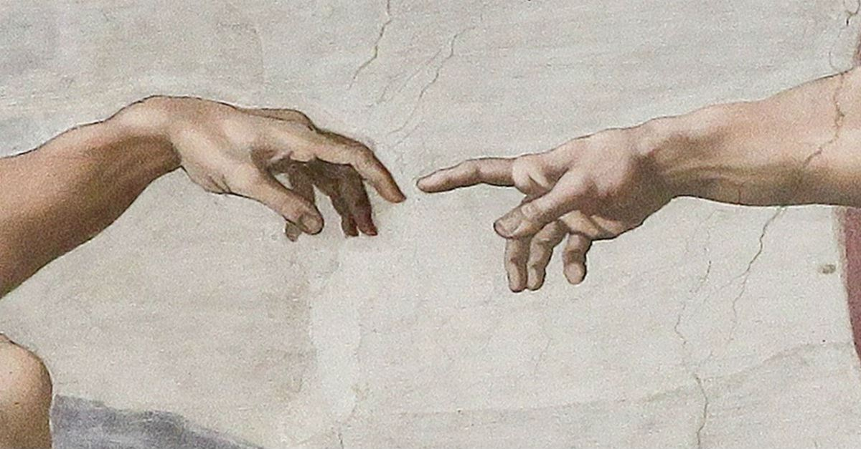

Imago Dei – 12th Comenius Conference

Invitation

You are cordially invited to attend the 12th Comenius Conference at Pápa Reformed Theological Seminary (Pápai Református Teológiai Akadémia = PRTA), Hungary, between the 22nd and 25th April, 2020. The theme is interdisciplinary in nature and covers a range of disciplinary areas such as biblical theology and anthropology, systematic and practical theology.

Conference costs
The conference registration fee for four days (22nd-25th April 2020) is 60 € (or 30 € for students), there is a daily registration fee of 20 € (10 € for students). This includes full participation of all conference proceedings, conference literature and refreshments.

Meals

The Seminary is unfortunately not equipped to provide breakfast, but there is an excellent bakery close to the conference venue which sells sandwiches, cakes, coffee etc.:
Lipóti Pékség és Kávézó (Lipóti Bakery), address: Pápa, Kossuth Lajos u. 22.

Other coffee shops/patisseries in the vicinity of the Seminary:

Pannonia Reformata (Café and Museum of the Reformed Church): https://www.pannoniareformata.hu/kavezo
Ricsi Cukrászda (Ricsi Patisserie): http://ricsicukraszda.hu/

All registered delegates are welcome to partake of all the conference lunches and dinners. In addition, Pápa has the following restaurants near the conference venue:

Hotel Villa Classica: https://classicahotel.hu/en/Etterem-Pub
Gólyafészek Restaurant: https://www.golyafeszekvendeglo.hu/index.php/hu/
Gambrinus Restaurant: http://gambrinus.hu/
Vitafit Restaurant: http://vitafit.hu/hu/
Intro Café: http://www.introcafe.hu/?utm_source=tripadvisor&utm_medium=referral

At these restaurants main meals cost between 5 and 13 €.

Accommodation

The Seminary has 15 modest guest rooms available which can accommodate up to two or three persons each (single beds only, each room has a private bathroom). Here, the cost per night, per person is 15 €. However, due to limited availability these rooms will be booked out on a “first come – first served” basis.

Pápa also has hotels and B&Bs:

1. Hotel Villa Classica: https://classicahotel.hu/en/Bemutatkozas

(Please note that in Hotel Villa Classica there is a concession of 20 % in the case of reservation for 1, 2 or 3 nights for the participants of the conference: 22.300 HUF/person/night + 450 HUF Tourist Tax/person/night; 24.700 HUF/2 persons/night + 450 HUF Tourist Tax/person/night. In the case of reservation for 4 or 5 nights there is a concession of 30 %: 19.500 HUF/person/night + 450 HUF Tourist Tax/person/night; 21.600/2 persons/night + 450 HUF Tourist Tax/person/night. These prices are valid ONLY if the rooms are booked directly from the Hotel. At the time of contacting the hotel please refer to Ibolya Balla who is happy to assist you in the process of reservation if necessary.)

2. Ditlin Boutique Hotel: http://ditlin.hu/
(The Hotel provides concessions depending on the number of guests and reserved nights in case of direct reservation. Please refer to Ibolya Balla when contacting the hotel.)

3. Caesar Panzió: https://caesar-panzio.business.site/

4-5: Belvárosi Panzió and Főnix Panzió:

https://www.booking.com/hotel/hu/belva-rosi-panzia3-pa-pa.hu.html?aid=319917;label=papa-8qBsYRgwnHoeDqxkh_NPTwS17332722884%3Apl%3Ata%3Ap110%3Ap2260.000%3Aac%3Aap1t1%3Aneg%3Afi%3Atiaud-146342138470%3Akwd-17368578160%3Alp9063017%3Ali%3Adec%3Adm;sid=7a1d50e0a678d12b5883a33fc68eb90b;dest_id=-863934;dest_type=city;dist=0;hapos=5;hpos=5;map=1;room1=A%2CA;sb_price_type=total;sr_order=popularity;srepoch=1559156659;srpvid=b75786198d7101d7;type=total;ucfs=1&#map_closed

https://www.booking.com/hotel/hu/fonix-panzio.hu.html?aid=319917;label=papa-8qBsYRgwnHoeDqxkh_NPTwS17332722884%3Apl%3Ata%3Ap110%3Ap2260.000%3Aac%3Aap1t1%3Aneg%3Afi%3Atiaud-146342138470%3Akwd-17368578160%3Alp9063017%3Ali%3Adec%3Adm;sid=7a1d50e0a678d12b5883a33fc68eb90b;dest_id=-863934;dest_type=city;dist=0;hapos=8;hpos=8;room1=A%2CA;sb_price_type=total;sr_order=popularity;srepoch=1559156659;srpvid=b75786198d7101d7;type=total;ucfs=1&#hotelTmpl

(Belvárosi Panzió and Főnix Panzió offer the participants of the conference the following prices in case of direct reservation ONLY: 7990 HUF/person/night + 450 HUF Tourist Tax/person/ night; 8990 HUF/2 persons/night + 450 HUF Tourist Tax/person/ night; 10990 HUF/3 persons/night + 450 HUF/person/night. Please refer to Ibolya Balla when making your reservation.)

6. Dunna: https://www.booking.com/hotel/hu/dunna.hu.html?aid=319917;label=papa-8qBsYRgwnHoeDqxkh_NPTwS17332722884%3Apl%3Ata%3Ap110%3Ap2260.000%3Aac%3Aap1t1%3Aneg%3Afi%3Atiaud-146342138470%3Akwd-17368578160%3Alp9063017%3Ali%3Adec%3Adm;sid=7a1d50e0a678d12b5883a33fc68eb90b;dest_id=-863934;dest_type=city;dist=0;hapos=6;hpos=6;map=1;room1=A%2CA;sb_price_type=total;sr_order=popularity;srepoch=1559156659;srpvid=b75786198d7101d7;type=total;ucfs=1&#map_opened-auto_open

If you do require accommodation at the Seminary, the following modus operandi will apply:

On receipt of this form, we will immediately contact you to confirm availability of said accommodation. If you do request a bed at the Seminary and if for any reason there are no beds available (and/or you are not prepared to share a room with another delegate), we will immediately advise you to make alternate arrangements and we are happy to assist you with reserving accommodation in town.

Parking

There is a closed car park at the Seminary that can be used by the participants free of charge.

Payment

To help save you unnecessary bank charges, all accounts should be settled upon arrival at the Seminary in Hungarian Forints (except for those who stay at hotels and settle their account there).

Places of interest in Pápa

Pannonia Reformata Museum of the Reformed Church: https://www.pannoniareformata.hu/

Blue Dye Museum: https://www.inspirock.com/hungary/papa/kekfesto-muzeum-bluedye-museum-a5399468921

Great Church of Pápa, address: Fő tér (Main square)

Esterházy Palace: http://esterhazykastely.papa.hu/?language=en

Thermal spa: http://papaivarkertfurdo.hu/

REGISTRATION FORM

All information supplied will only be employed for the purposes of registration.

Personal Details
Surname
Name
Title
Affiliation
Telephone |  |  |  |  |  |  |  |  |  | Mobile
Email
Special requirements (e.g. diet or disability)
Lunch |  | 23rd April |  |  |  |  |  | 24th April |  |  |  | 25th April
Dinner |  | 22nd April |  |  |  |  |  | 23rd April (Banquet) |  |  |  | 24th April (Excursion with dinner)
I wish to request accommodation at PRTA (15 €/person/night) for the following nights:
21st  April |  |  | 22nd  April |  |  |  |  | 23rd  April |  | 24th  April |  |  | 25th  April
I am a student
Basic conference fee |  |  |  |  |  |  | Normal (4 days): 60 €  Daily (normal): 20 €  Please indicate number of days |  |  |  | Student (4 days): 30 €  Daily (student): 10 €  Please indicate number of days
I would like to use the car park at PRTA
I need transport from Pápa railway station to PRTA

Please complete the registration form above and then submit it via email to Ibolya Balla (karib34@hotmail.com; +36-30/443-6076) by no later than the 25th February, 2020.

